[1]

Practice 2. Developing the PCB (Layout)

First Team Member, Second Team Member, …

*Objectives*—

**Develop the connection diagrams (layout) from the schematic diagram.**

*Index Terms*—layout, pcb, microcontrollers.

# INTRODUCTION

M

ICROCONTROLLERS are all around the world. Each day, Microcontrollers, are more present in the many aspects of our lives: in our work, inside our houses, and in more. We can find them controlling small devices like cellphones, microwaves, washing machines, and televisions.

A microcontroller is one device or chip that is used to govern one or more processes. For example, the controller that regulates the room temperature of an air conditioner; it has a sensor that continuously measures the internal temperature and, when the preset limits are exceeded, it generates the necessary signals to adjust the temperature.

# State of the Art

## The practices and the PIC microcontroller

The main objective of this practices is to provide students the foundation to fully understand the operation of the PIC18F45K50 microcontroller. This will be achieved through 11 documents that will guide the reader to create their own electronic card or Printed Circuit Board (PCB) and to be able to program it; in order to, execute different functions.

The advantages of ta PIC microcontroller to others on the market, which is why it will be used throughout this manual, are as follows:

* Easy to operate.
* There is enough documentation to work with it and it’s easy to obtain it.
* The price is comparatively lower than its competitors.
* It has a high operating speed.
* Development tools are cheap and easy to use.
* There are a variety of hardware that can record, erase and check the behavior of PIC.
* Once you learn to handle a PIC, it will easier to handle any other models of microcontrollers.

## KiCad EDA Software

KiCad is an open source software suite for Electronic Design Automation (EDA). The programs handle Schematic Capture, and PCB Layout with Gerber output. The suite runs on Windows, Linux and macOS and is licensed under GNU GPL v3. The first release date was in 1992 by its original author, Jean-Pierre Charras, but is now currently under development by the KiCad Developers Team [1].

# Results

In this section, you must report the outcomes of the laboratory activities.

## Follow the next ‘Layout Configuration’ Steps

1. In the same project from practice 1, click on the icon ‘**Assign PCB footprints to schematic symbols**’ . By doing so, you will be able to watch the footprints associations in a list format.

***NOTE:*** *If a ‘****Confirmation****’ window pops to reassign all the components to a new library format, click ‘****No****.’*

1. Now it is time to add the corresponding libraries to the **Cvpcb** program. Download from Blackboard the modules needed for the project in [2]. Click on **Preferences→Manage Footprint Libraries…** and in this way you will be able to add the modules from the folder named ‘**modules**.’ Click on ‘***Project Specific Libraries…***’ tab, then click on the button ‘**Browse Libraries…**’ and search for the folder where you save the modules. Select all the files and click ‘**OK**.’ Fig. 1 shows the result of the added modules.

***NOTE:*** *Your KiCad EDA Software must be in english to add the modules.*

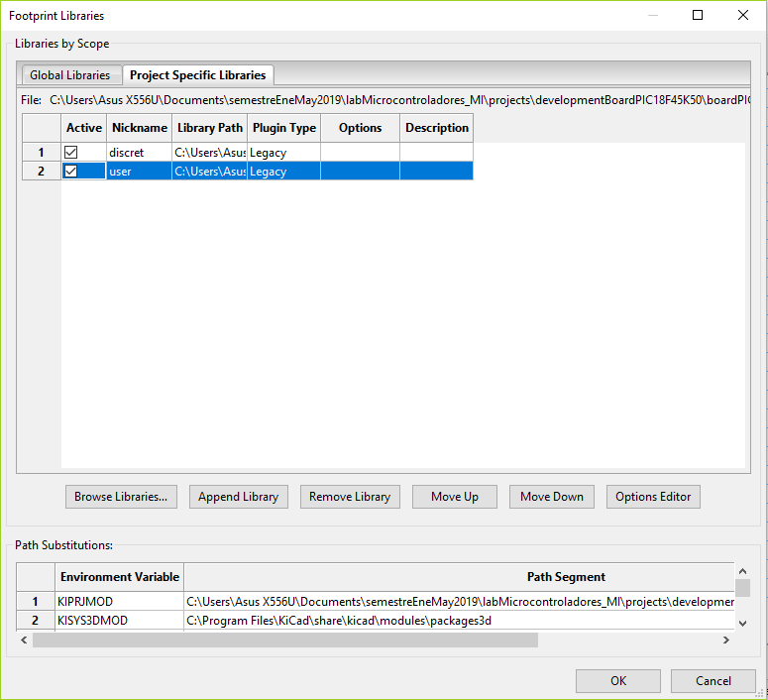

Fig. 1. Kicad Project Manager Window.

1. Once that is done, you must associate the list of components with its respective footprint using Table I for guidance. Be sure to activate the option ‘**Filter footprints list by library**’  from the **Cvpcb** toolbar. To associate the components showed in the middle column, double click with their corresponding footprint from the right column.

***NOTE:*** *Search all the footprints in the ‘****user****’ and ‘****discrete****’ added libraries that should be found at the end of the list.*

TABLE I

Component Footprint Association

|  |  |  |
| --- | --- | --- |
| **Name** | **Footprint name** | **Schematic Image** |
| Polarized Capacitor | user:Capacitor_elect |  |
| Resistor  **NOTE 1** | user:Resistor |  |
| Led | user:Led |  |
| Push button | user:DTS-6 |  |
| Non-polarized capacitor | user:Capacitor |  |
| Pot | discret:RV2X4 |  |
| Pinheads | user:pinhead-?X?? |  |
| Max232 | user:Maxim232 |  |
| Serial Connector | user:Conector_F09HP |  |
| MCP9700A | user:MCP9700A |  |

**NOTE 1:** *For the resistor of 470 ohms near the Max232, use the footprint of ‘****user:Resistor_large****.’*

1. Save your modifications by clicking ‘**Apply, Save Schematic & Continue**,’ and then click ‘**OK**.’
2. After that, you may close the **Cvpcb** and go back to the **EESchema** (Schematic Editor.) Save your project by clicking on **File→Save**. Close the editor of the Schematic and switch back to the ‘**Project Manager**.’

## PCB Layout Design

1. Once you have the design of the circuit on the schematic, it is time to generate the ‘layout’ of our PCB using the Netlist file. On the **Project Manager** program from **KiCad**, click on the icon ‘**PCB layout editor**’ . A new window will appear from the **PCBNew**. Click ‘**Yes**’ in the confirmation window.
2. On the toolbar menu from the **PCBNew** click on the ‘**Page Settings for paper size and texts**’  and modify the size settings to ‘**USLetter 8.5x11in**.’
3. After that, it will be time to focus more on design concepts. You may do so by opening the menu of ‘**Setup→Design Rules…**’ A window like Fig. 2 must show on your screen. On it, some final design characteristics will appear with many millimeter values. Between them, you should find the ‘**Clearance**’ specification which is the smallest spaces that it must exist between the tracks on the PCB. You shall set the value of this cell to **0.508 mm (0.020 inches.)** Next, we set a value of **1.200 mm (0.047244 inches)** on the cell of ‘**Track Width**.’ The other cell values must be set like shown in Fig. 2.

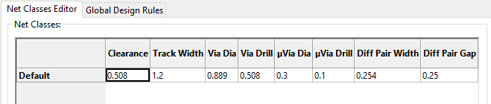

Fig. 2. Net Classes values.

1. Switch now to the ‘Global Design Rules’ tab and write, if needed, the minimum values for each an every one of the parameters on the ‘Minimum Allowed Values’ box, as shown in Fig. 3. Click ‘OK.’

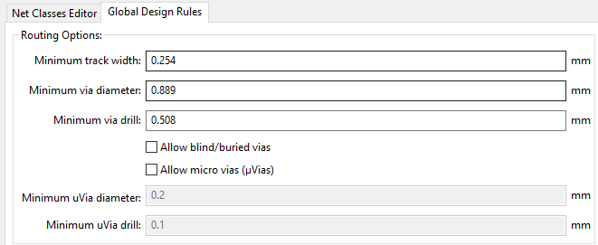

Fig. 3. Global Design values.

1. Time to import the Netlist file. Go to the toolbar ‘**Tools→Update PCB from Schematic…**’ and then click on ‘**Update PCB**.’ **When you close the window all the components will appear on the screen**.
2. Check in the ‘**Layers Manager**’ window (located at the right part of your screen) that all the needed boxes are checked, as shown in Fig. 4.

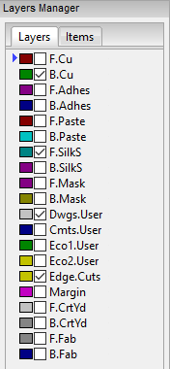

Fig. 4. Layers Manager window.

1. Now you have to define the limits of the PCB. First, highlight the ‘Edge.Cuts’ layer as follows: . Then, select the ‘Add graphic lines’ tool  and began to trace the original measures of your copper board (15x20 cm.) You must also define the cutting area; do not forget to add a 2.5 cm margin around the board. To measure the lines, you can use the ‘Add dimension’ tool  located on the right
2. It is your turn to move all the components in the circuit in order to avoid any track intersection inside the working area. You can move the components by positioning your mouse pointer above it and pressing the **key [G]**. All the components are connected to each other by a group of wires called **ratsnest**. Make sure that the icon of ‘**Hide board ratsnest**’  located in the toolbar of the left is highlighted.
3. Now you must link all the connections of you PCB. But before that, you must change the drawing option from the right toolbar from ‘Edge.Cuts’ to ‘B.Cu (PgDn)’ (B->Bottom, Cu->Copper.) as shown in Fig. 4.

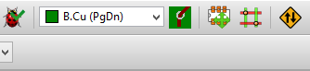

Fig. 4. Bottom Copper layer selection.

1. Start to connect your tracks to each and every one pin on the schematic by using the icon ‘Route Tracks’ . Trace all the routes for each net or connection in your PCB design.
2. Once your are done, save your layout File->Save or using the command [Ctrl + S].
3. Your board must look like the image located at the end of the document, Fig. 5.

### ***Report:*** For this practice, modify only the Section IV and your names at the top of the document. Upload the modified document to Google Drive.

### ***File Uploads:*** Create a ZIP with the next file extensions: .pro and .kicad_pcb, that were created once you completed all the steps of the document. Upload the ZIP file to Google Drive.

### 

### **Demonstration:** Screenshot the image of the complete layout and upload it to Facebook. Also, show the instructor your design.

# Conclusion

## In this section, you should add the conclusions, suggestions, and/or problems of the laboratory activities. Each team member must add his/her own conclusion (5 lines as minimum for each member).

References

1. B. Trinkel, “Fluid Power eBook- Fluid Power Basics,” in Hydraulics & Pneumatics magazine, 1st ed., Penton Media Inc., June 2007.
2. R. Peña, “Symbol Modules,” [Online] Available: Blackboard -> Laboratory Information -> Software -> Kicad Libraries and Modules -> modules

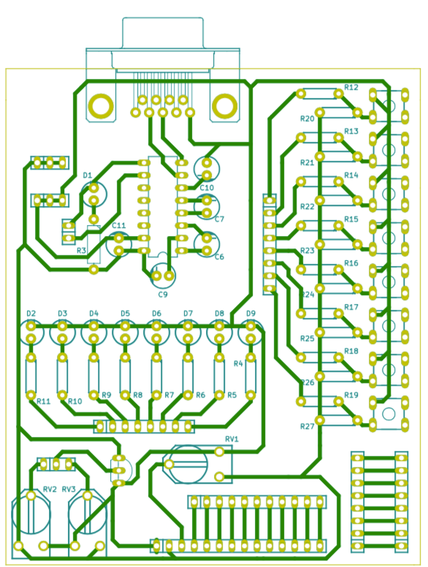

Fig. 5. Complete Layout of your PCB design

15 cms

10 cms

cms

20 cms

15 cms

2.5 cms

2.5 cms

1. This paragraph of the first footnote will contain the date on which you submitted your report for review.

   The next few paragraphs should contain the authors’ current affiliations, including current address and e-mail.

   Ph. D. Raúl Peña Ortega is with Tecnologico de Monterrey, as a Professor (e-mail: raul.p.ortega@tec.mx).

   M.C. Salvador Rodríguez López is with Tecnológico de Monterrey, as a Professor (e-mail: salvadorrdzlop@tec.mx).